Cutlass Bearings
from the
Sailnet Tayana List

Here is a synopsis of procedures for cutlass bearing replacement and prop shaft removal. The bearing can also be removed without shaft removal on a V-42. On a T-37, cutlass bearing replacement may sometimes be done without removing the housing if the shaft is pulled first. Cutlass bearing housing removal is identical for both boats.

1) Remove the prop and zincs. Clean the shaft so the cutlass bearing will slide smoothly.
2) After marking the top so reassembly is the same, remove the cutlass bearing housing. The entire assembly unscrews after the four studs are backed out. Using the double-nuts, turn the inner nut counter-clockwise to unscrew each stud. After the four studs are removed, loosen the caulking a bit to ensure you are working with polysulfide and not 5200. Use something sharp or a hacksaw blade or dental floss. If its 5200, get the 5200 removal chemicals - you now have a huge job. Use a large pipe wrench (or better still – two, on the fins opposite each other) to rock the cutlass bearing housing back and forth to loosen the housing from the caulking. Then unscrew it counter-clockwise. Only use polysulfide (Lifecaulk) or 4200 when rebedding. If shaft removal isn’t needed, you can slide the housing off the shaft and replace the bearing (see #5 below).

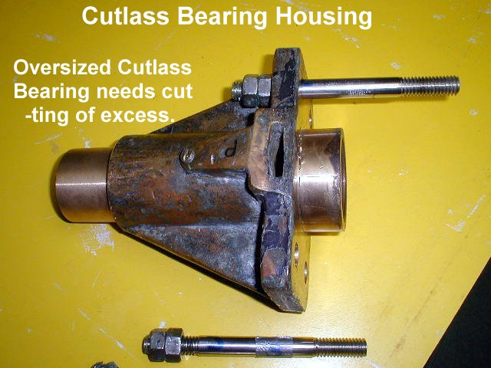
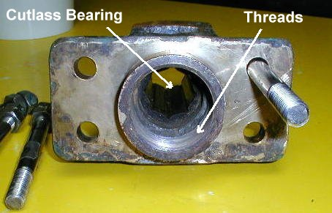
Cutlass Bearing Housing threads onto stern tube Oversize cutlass bearing prior to cutting (left)
3) Replace the cutlass bearing after undoing the two Allen set screws that hold the bearing in position. It can be pressed out of the housing with a hydraulic press or driven out using a block of wood to cushion the blows. Or cut a slot in the bearing with a hacksaw blade. This changes the diameter and it then comes out easily.
4) To pull the shaft, remove the coupling from the shaft after undoing the shaft coupling from the transmission. If the coupling is stuck, consider placing something no bigger than the diameter of the shaft (it should be large and substantial) between the transmission flange and the shaft. This object must not cover any of the coupling area. Then bolt the coupling back on to the transmission and see if you can pop the shaft loose. Don't use too much pressure here - if it doesn't work, you don't want to bend the transmission flange. The alternative is to slide the shaft aft and try a prop puller on the shaft/coupling combination or use a hydraulic puller/ram (if the yard has one).
Pull the shaft out. On a T-37, the shaft will clear the rudder easily and come straight back. On a V-42, the cutlass bearing housing must be removed to allow the shaft to be pulled far enough to the port side to clear the skeg. It will probably still hit the skeg and may gouge it. If it is too tight, cut away some of the skeg and re-glass later after the shaft is reinstalled. Be sure to have a machine shop check the shaft for being true (not bent). It doesn't even begin to clear the engine if the attempt is to remove the shaft by going forward.
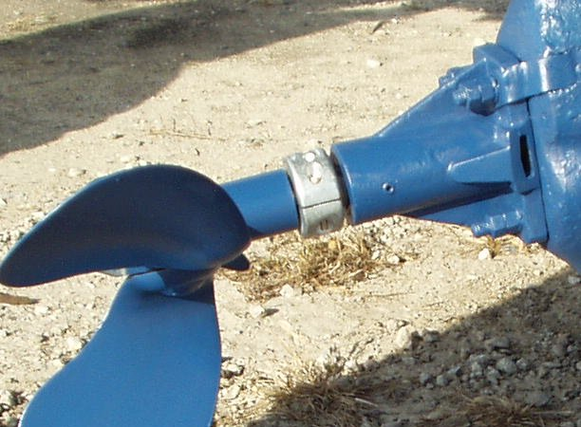
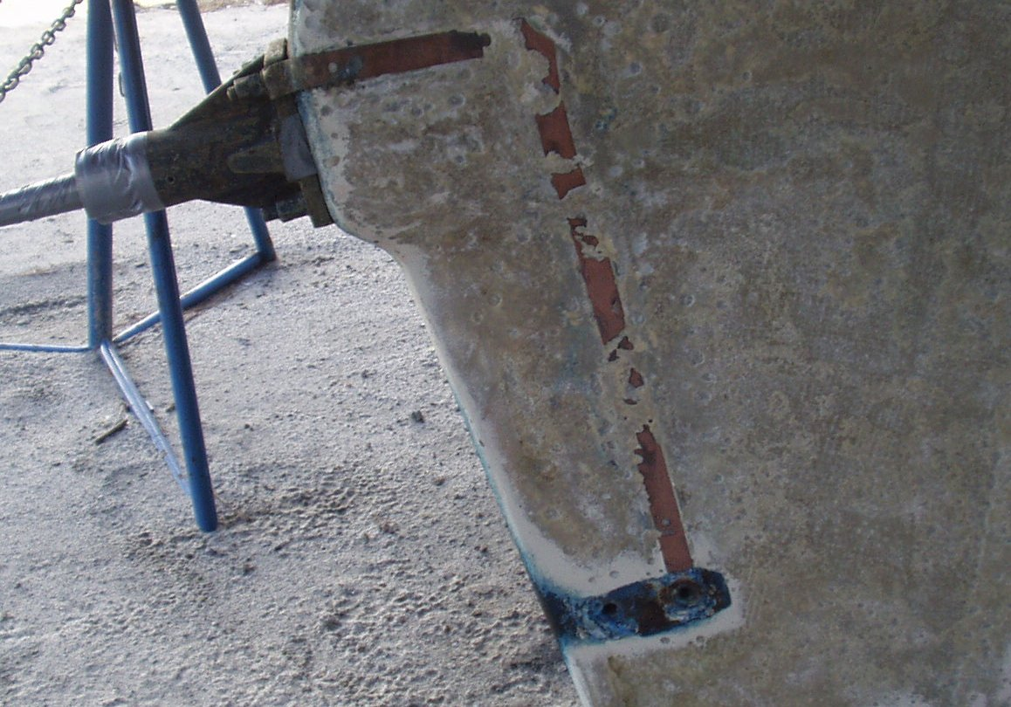
Cutlass Bearing Housing V-42 Cutlass Bearing Housing strap to hull zincs
5) To install, there is a clearance problem with the stern tube that the cutlass bearing housing screws onto. About two inches inside, the diameter decreases. This causes a sharp "lip" that the shaft will not clear if it is jammed up tight against the skeg. You need something metal and the same thickness as the "lip" to bridge the gap. I have used two or three hack saw blades taped together. This allows the shaft to be jammed in. I say jammed since on my boat I have to pull the shaft sideways and put a temporary bend in the shaft due to the shaft rubbing the skeg with a LOT of force. I then have a helper hammer the shaft in with a 2-pound hammer and a wooden block. Once it goes in a bit and clears the "lip", it is free to push in by hand.

6) Screw on the cutlass bearing housing. When it snugs up against the fiberglass/caulking, back it off until the stud holes line up and reinstall them - but not overly tight. Use Lifecaulk on the studs.
7) Replace the prop and zincs.
Wayne Strausbaugh V-42 C/C RESTLESS May 2006
__________________________________________________________________________________

John,
My V-42 takes a "Chub" cutlass bearing. It is 1 1/4" by 1 3/4" by 5". Not 1 7/8". But you can get custom sizes from Duramax:
http://duramaxmarine.com/bearings.htm
Wayne Strausbaugh V-42 C/C RESTLESS August 2003
__________________________________________________________________________________

Just a quick update of my stern tube and cutlass bearing replacement project in case someone is contemplating doing it, too.

After breaking three of the four studs which secure the stern tube assembly to the deadwood and then removing all parts of the broken studs from the deadwood area, I found that Tayana screwed the studs into deeply (two inches) embedded hex nuts located in the deadwood. All four hex nuts had short pieces of metal rod welded on each side of the nuts as anchors. They were the same deal I found when I replaced all my chain plate studs.

I removed each of nuts and filled the holes with thickened epoxy, a little at a time, until they were full. I am going to drill and tap the epoxy to accept bronze hex cap screws (1/2" x 3") in lieu of the studs. Hopefully, I'll be able to replace the cutlass bearings much easier in the future.

Again, I will post pictures on the ftp site when it is all completed.

Regards, John Keefe CT37 ODYSSEA Youngstown, New York August 2003
__________________________________________________________________________________

After removing the studs (and I must point out that the outside thread was already in bad shape even before I made matters worse), I became aware that the 4 existing nuts would not thread on regular 1/2 inch all-thread (my original plan) which meant that the all-thread would not go into the embedded female threads. Having made enough damage as it were, I did not force the issue and brought the original nuts and studs back to Tucson to a machine shop who identified the thread as 1/2 –12. This is an unusual but nonetheless valid thread, very close to the standard 1/2 -13. They were very busy and not too interested in my problem. The danger is that a regular 1/2- 13 nut will go in smoothly about one an a half turn leading some to believe that a little energetic wrench work is all that's needed and ruining the thread in the process.
As I was shopping for a 1/2 -12 die in a used tools shop, hoping I could restore the original threads enough to reuse them, the owner who did not know I own a boat or anything else about me, asks me out of the blue: Why would you need one of these? Are you working on some Taiwanese machinery? It was, as he told me, a known fact that all 1/2-12 came out of Taiwan and even had another name for it: The Taiwan f...up! Now, I'm just reporting this and will not vouch for its accuracy or veracity!

The machine shop eventually agreed to make 4 new studs using the original ones along with the nuts as a guide and they did a very good job at that. The part of the stud going inside the hull is 1/2-12 and the part sticking out is the standard 1/2-13 so I can use new nuts. End of another boat project saga.
Alain Provost Blue Moon T37 # 95 March 2004
__________________________________________________________________________________

You can check the cutlass bearing for play. Spray a little water into the cutlass bearing and then spin the prop with a flick of your wrist. If it "chatters" to a stop, it is probably time to change the bearing.
Wayne V-42 C/C RESTLESS Date Unknown
__________________________________________________________________________________
I agree that spinning the prop is not a scientific method for cutlass bearing condition but I was told years ago by a yard manager that it was a quick and easy way to determine that it needed changing for sure. I used to do it just as the boat cleared the haulout slip so I could see if I needed to schedule a day or two extra in the yard. I have changed a lot of cutlass bearings on my V-42 and confirmed it many times. The chatter is caused by excess clearances that can be easily verified by moving the shaft up & down and back & forth.
A little history - after I imported my boat from Taiwan myself, I decided to have it "professional commissioned" thinking I may not know as much as a Tayana dealer's "crew". The first thing they did was haul the boat out of the water with the aft lift strap around the bottom of the prop! As I looked on in awe at the "professionals" at work, the strap slipped off the prop and the boat started to drop! But the edge of the strap caught on the prop nut and stopped the fall. The sudden stop was cushioned by the bending of the prop shaft. Still in shock after seeing my brand new boat supported by a "nut", I let the "crew" talk me into having them straighten the shaft. Boy, have I learned my lesson! Assume the position and they will stick it to you every time...
I ended up changing the cutlass bearing almost every year. The propshaft was not perfectly straight and the engine alignment was suspect too. I used to get a high-pitched whine at certain RPM's between 1200 and 1800 RPM. Every time I changed the cutlass bearing, the whine would move to a slightly different RPM range. The cutlass bearing always showed excessive wear on one side or the other. After ten years, I finally changed the shaft and learned how to really align an engine well. Now no problems and it has been 7 years since I needed to change the cutlass.

Wayne Strausbaugh V-42 C/C RESTLESS Date Unknown

(Update 2006: it has now been 14 years and 25,000 miles since I changed the cutlass bearing.)
__________________________________________________________________________________
I found this on a web site.

(BSW means British Standard Whitworth.)
Another area that causes confusion is the fact that some BSW or BSF nuts can be screwed on UNF or UNC bolts and vice-versa. Under NO circumstances should this practice even be considered. Most of the coarse threads share the same threads per inch which means BSW nuts can be screwed onto UNC bolts and vice-versa. The exception to this being ^ inch -- ^ inch BSW is 12 threads per inch and ^ inch UNC is 13 threads per inch. Again, it must be emphasized that this practice should not be a consideration. Whitworth and UNC/UNF thread forms differ greatly, the primarily one being the thread angle (see illustrations). BSW and BSF feature a 55 degree thread angle (47 ^ degrees for BA) and UNC/UNF threads feature a 60 degree thread angle. Consequently, if these fasteners are interchanged, considerable loss of holding force, fatigue resistance and strength will result. Unfortunately, this author has seen examples of mechanics – unaware of these subtleties -- mixing fasteners at will -- gee, if it screws on it must be okay..!! (Scary thought).

Author Unknown March 2004
__________________________________________________________________________________

Does anyone have this situation?
The space along the drive shaft between the propeller and bearing is insufficient to place a 1 1/4 inch zinc collar around the shaft. Currently I must cut the zinc collar to allow it to enter the space and freely not interfere by rubbing or grinding this area.
Boat/US used to stock the correctly sized collars until they were acquired by West Marine, now they stock the West Marine part, which exhibits the same binding on my T-37. Last July I purchased the original Boat/US part from the following source:
Marshall Manufacturing,` P.O. Box 190, Atlantic, VA 23303
1-1/4 inch Shaft Donut Zinc at $5.95 each.
Gray s/y Aerandir March 2004
__________________________________________________________________________________

I'm curious about this. Kamaloha has had a zinc in that spot for as long as I've owned the boat; I just repeated what the previous owner had done. As you point out there is very little space between the zinc and the end of the cutlass - about 1/8". However, the aft cutlass fitting has slots in the sides with what look like little vanes to direct water flow coming aft into the bearing. I know that when I "burp" the PSS Shaft seal on the inside I get a prodigious water flow, so I don't think the zinc is blocking enough to hurt anything. The last time I pulled my prop shaft for inspection it and the cutlass appeared to be fine.
Charlie March 2004
__________________________________________________________________________________

Charlie,
The zinc collar on your boat's propshaft probably has minimal effect on water circulation within the cutlass bearing since water from your engine's seawater cooling system is injected directly into the PSS shaft seal/tube/cutlass bearing (in addition to what comes in through the lateral slots in the bearing). On boats with traditional stuffing boxes and no water injection, however, an anode placed too close to the cutlass bearing can restrict water circulation and the stuffing box will become warm to the touch.

You get lots of water when burping the PSS shaft seal due to the pressure differential inside/outside the boat. However, that pressure differential doesn't affect water circulation within the seal/tube/bearing once the seal is reseated. That's why PYI provides the hose barb on the PSS seal - so that water can be injected to keep the seal/tube/bearing cool.

Fortunately, you don't have to have a zinc collar on the prop shaft, you can bond the shaft with a shaft brush mounted inside the boat. Since it doesn't have to be replaced annually like most zincs, a shaft brush will actually save you money.

Sue Canfield March 2004
__________________________________________________________________________________

Does anyone have any suggestions on how to remove the 'cutlass bearing unit' from the hull??` I've removed the 4 bolts on the external mounting plate and tried to pull the tube and plate back off the shaft to no avail. Is there something I am missing???? Thanks.
Joe Ghiotti S/V Gale Rider Tayana V42-CC HN 091 October 2004
__________________________________________________________________________________

To remove the cutlass bearing housing, you have to put double nuts on the 4 threaded studs and back the threaded studs clear out first. After getting them out of the way, put a big crescent wrench on one of the fins of the cutlass bearing housing and unscrew it counterclockwise. It has very fine threads. Be gentle with the 4 studs as they are probably 1/2- 12 and hard to replace if damaged. Do not try to put a standard 1/2 - 13 nut on them if you feel ANY resistance. Remove shaft first, it makes it a lot easier.
Alain Provost October 2004
__________________________________________________________________________________

Subject: Cutlass Bearing Replacement

It only took 15 minutes to remove.. THANKS.. An observation is that the receiving plate on the other side is held the same way because there are still 4 studs/bolts there...
A question though: I am concerned that the studs I extracted by locking the two nuts and turning counterclockwise were bent at the base of the external threads. I can't imagine why? I remember when we first bought the boat 12 years ago and the commissioning yard did replace the bearing. I wonder if they bent them, of some other reason.????? SO I will try to have the studs straightened or get new. Any thoughts???

Joe Ghiotti & Terri Leone S/V Gale Rider Tayana V42-CC HN 091 October 2004
__________________________________________________________________________________

Get NEW studs! If they have been bent, they are stressed. If they are BSW (British Standard Whitworth) you can buy them from various specialized distributors, or have them machined by a good machine shop. If you have to go the latter route, they will cost about $20 per bolt. But don't risk trying to mate a BSW (1/2-12) with a SAE (1/2-13). It's not only the thread pitch that is different, it is also the angle of the groove, the rounding on the top of each thread, and the depth of thread.

regards, Harvey October 2004
__________________________________________________________________________________

Hi Joe,
With the shaft removed from our V-42, I used a hacksaw blade mounted in a "reduced clearance" holder and sawed two slits down the length of the cutlass bearing. (The water grooves provided guides.) A chisel removed the section between the slits and the bearing then practically fell out. In doing this one has to be careful to keep the saw parallel with the stern tube to avoid cutting into the tube itself. Probably one slit would work but the bearing may have to be pressed out using a reverse of the press described below.
To press in the new bearing, I cut the head off a 3/4" x6" fine-thread grade 5 bolt and welded it onto a length of 3/4" threaded rod which was then inserted into the bearing tube with a heavy washer and nuts at the packing gland end. The bolt at the other end extended through the new bearing and through another heavy washer with the fine thread nut just started. The fine pitch of the bolt provided the necessary force to draw the bearing into the housing when the nut was drawn up. When the fine thread nut neared bottom I backed the nut and advanced the nut on the other end of the threaded rod. As I recall, I used a vice grip on the threaded rod to keep it from rotating while I drew up the fine thread nut. After a few cycles of this process the new bearing was in place.
I think I would rather go though the process of removing the shaft to change the bearing rather than removing the bearing housing. (The nuts on the studs are probably Whitworth thread and not generally available in the US.) In my opinion, two nuts as lock nuts are unlikely to enable you to unscrew the studs from the housing. Further, the sealant and accumulated guck will make it very difficult to unscrew the housing without rolling the whole boat off the jack stands.
Good luck.
Merv Karelia V-42 CC October 2004
__________________________________________________________________________________

