Feathering Propellers

from the
Sailnet Tayana List

I have a T37 with a 4-108. According to my survey, the shaft is 1 1/4" and the Prop is 17RH11, 3 blade. I take it that means 17X11 right hand. Anyway, we pulled the prop just after purchase and installed an Autoprop. Our Autoprop's blade diameter is 17.13", and is "self-pitching".
Bryan T37 Serendipity April 1999
__________________________________________________________________________________

In this regard, has anyone tried the Autoprop? Because of its unique design, there is little or no prop walk with the water being directed straight behind it. I do not sell or market these props but the
difference mine made on my Tayana 47 was unbelievable with an added attraction of about a 20 to 25% savings in fuel and the ability to run my engine at a slower speed for the same hull speed thru the water. The fact that the prop will stop the boat in its own length either forward or reverse from 6 knots also is an added bonus, especially as there is no swing of the stern to either port or starboard. IT IS EXPENSIVE but every one is designed, built and tested to the requirements of your boat and engine.
Brian Strutt T-47 September 1999
__________________________________________________________________________________

Having the correct pitch allows the engine cylinder pressure to be a minimum relative value for the horsepower developed.
For instance (as extreme examples), if too low a pitch: lower rpm developed; hence lower horsepower.... and extremely high cylinder pressure ('lugging' ) , blown head gaskets, bent piston connecting rods, hammered mainshaft bearings, excessive engine wear, etc.
If too high a pitch: cavitating/eroding prop , scored cylinder walls, 'hammered' injectors and valve seats, excessive engine wear.
Most 'steady state' reciprocating engines 'like' to be run (long term) at near 75% of max. developed horsepower and at the 75% peak of their 'power curve'.
I like to select pitch so that I get 75% optimum rpm/horsepower output at the rated hull speed of the boat. Ever since Drs. Otto and Diesel invented their engines, the value for long life vs. maximum output has been around 75% rpm/horsepower output.
Look at the power curve 'optimum' value in your engine manual, match/record/correct that value near the hull speed of the boat and you optimize the whole system for economy, reliability, long life,
and extra power 'bursts' when you need it. For me its like religion, politics, taking risks, etc.;... I like to be in the 'middle'.
The Autoprop tends to automatically adjust for the 'optimum' all along the engine power curve. (I just think they are outrageously expensive, as I can almost do a whole engine rebuild for the price
of an Autoprop.).
Rich Hampel T-37 March 2000
__________________________________________________________________________________

My experience from talking to others is that if you have a well-pitched prop, a Max-Prop will not gain you any speed and may, in fact, lose you a bit of speed. The shapes of the blades are rather abrupt at the corners. As a feathering prop under sail, it provides 15% less drag than an Autoprop. The Autoprop will almost always give you a half-knot better speed and 10 to 20% better fuel specs. Since the prices are similar, I recommend the Autoprop.
Wayne V-42 C/C RESTLESS December 2000

(The Max-prop web site lists forward efficiency of a Max-prop as 96% of a 3-blade fixed propeller)
__________________________________________________________________________________

In my humble opinion, nothing can tame the "drunken elephant", only sober it up a little.
We put an Autoprop on "Tundra Spirit" a T37 almost 4 years ago. We have a Perkins 4-108 and fluid drive transmission. We love the prop, however am not sure we would go through it again if we had to. We knew up front that the shaft would have to be shortened. We were replacing the shaft anyway and just had it made shorter. We also knew that the cutlass would have to be cut in 1/2 and after checking with the yard manager where the boat was on the hard and getting his opinion that it would be o.k., we cut the cutlass in half. As a side note, we check the cutlass each year when she goes on the hard and after 3 1/2 years it is still good. Now, after all of the above being completed and the prop installed, I swung the rudder hard over, both port and starboard and the blades hit, so I had to shave some (about 3/4 inch) off the rudder. Needless to say, I was not a happy camper.
As stated above, we love the Autoprop, however it was a real hassle installing it on our T-37. Other T-37's may not have had the same problems. The only other thing that I might mention is that the Autoprop folks suggest a shaft brake as the prop has a tendency to rotate when you are sailing along at 5 1/2 to 6 knots. We do not have the brake and it does rotate slowly at those speeds. The only thing I can not tell you is how "Tundra Spirit" was before the Autoprop as I was never behind the wheel with the old fixed prop. We do stop very well and she backs up without much pull to one side. But I don't care what kind of prop you have (again, my humble opinion), if you have a cross wind and a cut-away forefoot boat like the T-37, the bow will blow to leeward and there is not much you can do about it except have some long lines and help from the dock, or back into the wind until you can turn. I will tell you that every time we pull the boat, we get a crowd around our prop attempting to figure out how the thing can possibly work. It does work !!
Bryan and Linda Biesanz T-37 "Tundra Spirit" July 2001
__________________________________________________________________________________

This theme might equally be called "Can a Tayana 37 Be Steered in Reverse?"
Perhaps someone can define the benefits and disadvantages of an adjustable auto-vaning prop. I have heard claims that it provides control in reverse for a full-keel boat such as the T-37. I have also heard that it improves performance in reverse. Other comments are that they are outrageously expensive for what they provide, and others say that it is well worth the cost for the control they provide.
As far as controlling a full/semi-full keel boat, my impression from the comments is that the benefits are detectable, but marginal. Is this true?
Would you be better off investing the money in a bow thruster? Will additional practice help overcome the problems of steering in reverse?
I am still in a bit of tizzy when I have to control the boat in reverse any place but in a wide-open lagoon with no boats around, and lots of depth. But I can also say that after three years of sailing our T-37, backing up gets slightly easier with practice and experience - but oh so slowly! Most of the time I wish we had an end-tie. I usually consider it a miracle that we managed to pull into our slip without disaster. Backing out of the slip elicits a combination of silent prayers and audible curses. Would an Auto-prop/Maxi-Prop suddenly make me into a skilled pilot? But after 40 years of sailing, I can only recall two boats that I have ever sailed that could back up in a reliable manner - a Bristol 34 and a Hunter 355. I recently met a very nice elderly gentleman in Canada on a Catalina 42. Almost brand new, shiny, etc. It was his third of fourth Catalina. We started to chat about our different boats. His final comment was something to effect - "Great, so I can back up and make a sharp right turn with my boat. But once out in the ocean, that doesn't seem to matter all that much." His conclusion was that it's all a trade-off between a boat like the Catalina 42 and the Tayana 37. He seemed to suggest that when the chips were down, he would sooner tolerate the difficulty in backing up than the higher risk of dealing with heavy water.
Then there are the boats that really can do both very well, like the Bristol 34, and reportedly, the Valiant 40, and such.
I rather like the strategy of screaming "No Insurance". But too much of the time, there's no one around to hear me shout.
regards, Harvey Karten July 2001
__________________________________________________________________________________

On the discussion of Autoprop verses Max-Prop and other units that carry a high price I looked into Bill Maloney's suggestion and inquired about the "Kiwiprop".
This is their response:
Thanks for your interest in our unit.
Attached is a copy of the standard warranty that comes with every unit and a customer specification sheet we would ask you to complete were you to proceed further.
We are familiar with the Perkins unit and have fitted a number of props to the 4.108 & 4.107 in each case with 2:1 reductions.
Assume you have the 2:1 box then you would need a 17" unit. Price would be US $ 1250 delivered DHL 5 ~ 10 days after dispatch.
The prop is certainly owner maintainable, with just 3 grease points on the blades and 2, one fore one aft on the boss. Blade replacement if ever needed takes just a minute with no need to remove the prop, in fact it can be done underwater with a bottle.
We do not have agents in the US, and can only offer these prices by dealing direct. The unit is very robust and we have never had a structural failure in over 100 units with the high tine units over 4 years of service.
We can include a spare blade with the order if that gives some comfort, but being 40 % glass reinforced Du Pont Zytel, they are very tough and have not proved a problem in the power range we are dealing with.
Remember 3 blades = 33 % of the work per blade, a significant stress reduction on a 2 bladed prop.
Please let me know if there are any other issues I may be able to answer for you.
We are confident our unit will perform very well on your vessel.
Cheers, John Blundell Phone: + 64 9 5757 975, see www.kiwiprops.co.nz August 2001
__________________________________________________________________________________

After taking a look through the Kiwi-prop web site I am considering fitting one of these props to my T37. I guess my concern is the strength of the blades when they come into contact with foreign objects. (we have a lot of Coconut's floating in the water as well as a lot of other debris. From what I could get from the Kiwiprop literature the blades are a lot thinner that the bronze Autoprop or Max-prop blades and they are made from a 40 % glass reinforced Du Pont Zytel . I have no idea what Zytel is. Do you know anyone who is using one of these props?
Regards, Phillip Brassington August 2001
__________________________________________________________________________________

Hi Phillip,
I believe zytol props are used on some of the larger outboard motors (according to Kiwiprop’s). I don't know of anyone who is using the Kiwiprop so I can't be of much help in that regard.
The purpose of my email relates to a conversation I had with John Blundell of Kiwiprop. I asked him about pricing and he quoted me NZ$100 per inch, hence a 17" should cost NZ$1700. This converts to about US$714 using an exchange rate of 0.42. Obviously this excludes freight and any import taxes.
I felt anyone contemplating buying a prop should know the price quoted to me, as a local over the phone. One might like to say that one of our members who lives in Auckland was quoted NZ$100 per inch.
I will try and find someone who has had first hand experience with a Kiwiprop to comment.
Regards, Bill Moloney Covenant III #34 August 2001
__________________________________________________________________________________

Help!
Have any of the T-37 owners on the list fitted their boat with a feathering prop? I had Bold Venture fitted with a new prop shaft with standard taper with the intent of buying an Autoprop and putting it on in the water. I sent them a tracing of the aperture and shaft to insure that I wouldn't have any problems and that it would not hit the rudder or dead wood. I just heard back from them that an Autoprop won't work without making modifications to the rudder, which I am not inclined to do, because I don't want to haul again just yet. If any T-37 owners have fitted feathering props, I would very much like to hear what they have and how satisfied they are with it. I have a borrowed prop on the boat now so I will have to make a decision soon as to whether to buy another fixed prop or feathering prop. I would prefer feathering if I can find one that will work and can be installed in the water.
Regards, Gary date unknown
__________________________________________________________________________________

This is disappointing to hear (that an Autoprop won‘t fit easily on a T-37). I knew there were problems with the Max-prop but had been told the Autoprop would work.
I am going to look at one called Hydralign, www.hydralignprop.com/. They make a version that is billed as an "aperture" version. The local prop shop says it will work on the T-37.
John Lewis January 2003
See the Autostream, Hydralign, Slipstream, and Kiwi Feather props at www.westbynorth.com
__________________________________________________________________________________

I have a Luke feathering prop on my T37. No modifications to the rudder or aperture were required. See: http://www.peluke.com/ for info.

I like it. I had a new shaft machined to replace the Chinese original. The Luke prop has a 17" diameter. Backing is somewhat improved, although I have never thought the T-37 to be that bad in backing up with the 18" x 12" 3-blade prop. The boat sails better w/out the drag of the fixed, 3-blade prop. A negative is that the Luke prop needs to be lubricated (greased) every 3-4 months. This entails having a diver attach a grease gun to a screw-in port on the prop and pumping in some grease. The Luke people are true New England craftsmen and they build a good product and stand behind their work.

James W. Smiley Isle of Palms, SC January 2003
__________________________________________________________________________________

I have family in New Zealand and this prop looks like it might be worth the cost. Any comments on a feathering prop for a T-37? Website reproduced below:
http://www.santotoday.com/gowestsf/feathering_prop.htm
Bill McMullen December 2004

Autostream Feathering Prop

We bought a new feathering prop in New Zealand. I have kicked myself all the way across the Pacific for spending $3,000 US on a genaker rather than on a Max-Prop before we left the US. We almost never use the genaker but we would be using the feathering prop every time we were under sail.
Now I am glad I waited because it turns out the these props are a lot cheaper in New Zealand. The Max Prop for our boat was only going to cost about $2,000 US but having adjusted to New Zealand prices I decided to dig a little more and see what I could find. We decided on an Autostream prop which was just slightly more than $1,000 US in New Zealand. It is made in Australia and available in the US but again it is a lot more for the rich Americans.
It has pitch adjustment for both forward and reverse without disassembly which was an option on the Max Prop for another grand. It seems to be well made and it is the top selling feathering prop in Australia. The Max Prop is a beautiful piece of engineering and I am sure that this prop doesn't quite measure up but it has worked really well so far and we didn't need to modify the shaft so we can put the fixed blade prop back on if we have a problem. I don't think we will. It seems to be a quality product and with a very attractive price. If you want one in the US you could probably save enough money to pay for a plane ticket by traveling to Australia and picking it up.
Our boat performs so much better I am amazed and I had high expectations. You may notice the blue ink on the prop. It is a permanent marker that contains printers ink. It was given to us by Kim on Rival Chief. It has kept the growth off the prop for 6 weeks so far and got us out of New Zealand with non of the dreaded tube worms attached.

Jim Island Packet 38 From the Internet…
__________________________________________________________________________________
Subject: Autoprop Maintenance Costs

The Autoprop doesn't need greasing. My version of the prop has bearings that are not only exposed to the water but are lubricated by it as well. I have heard that some newer versions have sealed bearings.

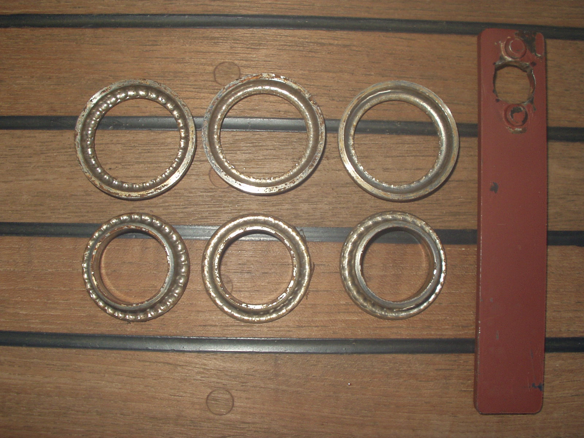
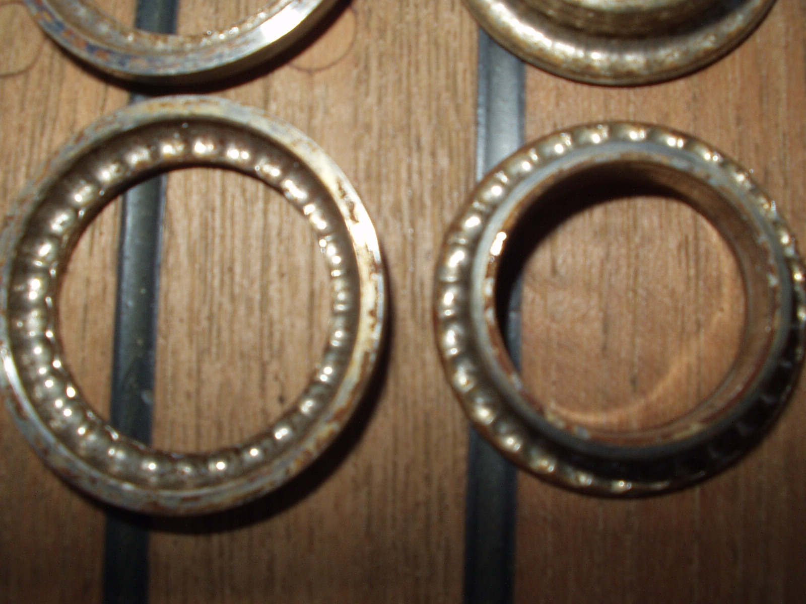
My problem is bearing race wear and it is not inexpensive to repair. When I got my prop, I motored over 7000 miles in 3 years. The boat was never hauled. The prop worked fine. Now, that's a lot of miles – probably much more than the prop was designed to go without maintenance. When I overhauled the prop, the bearing tolerances were out of spec (a sure sign that maintenance was needed) and most of the replaceable, inner bearing races were in bad shape. The SS races had lost about half their mass and started to get pretty thin. There were depressions in the races where the bearings were located. The bearings no longer moved around the race but seemed to rotate within each little
Autoprop bearing races & assembly tool Ball-bearing indentations in races

depression. The outer races are machined into the prop base itself and were still perfect. Overhaul was fairly easy. The new races and bearings cost over $200. But still the prop worked fine. I am now going to inspect every 2500 miles and plan on replacement at 5000 miles. I still like the prop a lot! And since my fuel mileage is increased by about 20% that in itself probably pays for the bearing and race overhaul kit.
I understand that using one on a T-37 poses clearance problems and requires a slight reshaping of the rudder plus cutting the cutlass bearing housing. But there are at least two T-37’s out there that use the Autoprop.
Wayne V-42 C/C RESTLESS December 2002
__________________________________________________________________________________

When I first got Southern Cross, she had a 17x12 prop, driven by a Yanmar 4JHE. This was definitely too small, but probably the original. At 2600rpm, I got about 5.6kts. The engine would also easily exceed max RPM. I now have an Autoprop, 470-H5 (18.5 inches), and at the same RPM I get about 6.5kts and it won't over rev anymore.

Paul s/v Southern Cross V42-cc May 2005
__________________________________________________________________________________

We have an 18" Max Prop on Magic Dragon. When we bought the boat, the previous owner had decided it was under-propped and had adjusted the pitch up a notch, so we were unable to make more than 3000 RPM with the Yanmar 4JHE. The stern would squat severely and black smoke would boil out of the exhaust at that engine speed.

I repitched the prop back down last year and the engine seems much happier. I don't remember exactly what the exact pitch measurements were/are. They're in my logbook on the boat. I'll look this weekend and report back.

If you are thinking of replacing the prop, I would definitely recommend ponying up the extra $$ and going with the Max-Prop or Autoprop. More speed under sail, and greatly improved backing ability.

Frank Timmons V42 Magic Dragon May 2005
__________________________________________________________________________________

From the folder on the FTP site about Autoprop: ftp://tognews.com/AutoProp
RESTLESS: Tayana 42 Cutter
31,000#, 33 ft waterline
double ender
Perkins 4-108 (49 HP)

RPM Old (16X13 3-blade) AUTOPROP (18 1/4)
(29,500#- displacement during test) (31,000#)
850 3.4 Kts
1300 ---- 5.0
1400 ---- 5.2
1500 4.8 5.4
1600 ---- 5.6
1700 5.5 estimated 5.9
1800 5.8 6.3
1900 6.1 6.4
2000 6.3 6.6
2100 6.5 6.8
2200 6.8 7.0
2300 6.9 7.2
2400 7.2 7.4
2600 7.6 7.8

Two Tayana 42’s: 5.8 Kts at 2300 RPM
(took another in tow - 92° day, 85° water temp)
Engine temp rose only 4° - towed for an hour.

Note: RESTLESS had original factory prop repitched 3 times from 18X10, to 17 1/2X11, to 17X12, & finally 16X13. Max speeds with 18X10 were 6.3 to 6.5 Kts. Cruise speed was 5.8 at around 2000 RPM.

CDR Wayne Strausbaugh, USN, retired
__________________________________________________________________________________
AutoProp
by Wayne Strausbaugh
Since I have experimented with 4 or 5 variations of 3-blade props, a discussion of my Autoprop is best preceded by a history of performance with other propellers. I have a Tayana V-42 center cockpit with a Perkins 4-108 and a Hurth 150 transmission running a 1.95:1 drive ratio. I have repitched the original prop 3 times, tried a prop of a different brand and finally gone to an Autoprop. What I have learned probably applies to all heavy cruising boats in general but the following is more germane to those with a transmission ratio of around 2:1.
The original factory prop was 18X10 and gave a max speed of 6.3 to 6.5 Kts. Cruise speed was 5.8 at around 2000 RPM. I repitched it 3 times from 18X10 to 17 1/2X11 (no change in performance), 17X12 (picked up a few tenths of a knot and lost a bit of "thrust" at low speed), & finally 16X13. The smaller prop is a "speed" prop. That is, it is optimized for speed in calm water. Speed went to 5.8 at 1800 RPM with about 6.3 Kts at 2000. Top speed was 7.6 but the engine would immediately start to increase engine water temp. Seven knots was sustainable at 2300 RPM. Low-end thrust suffered greatly with the small prop. Acceleration was cut in half and the boat had a hard time maintaining speed with any wave action on the bow. Moderate pitching (3 to 5 feet) resulted in 4 knots or less. But the boat cruised well in the ICW and motor sailed well. The bottom line here is that a smaller prop with more pitch equals better speed but less thrust. I tried another brand of 3-blade prop (maybe a Michigan?) with a pitch of 16X13 but it had a slightly different shaping of the blades and the engine could hardly pull 2000 RPM. I repitched it to 16X12 and it was satisfactory but never equaled the performance of the original Tayana prop. The Tayana prop had wider and thicker blades.
Then I got an Autoprop. The Autoprop was easy to install on a V-42. It is a 18 1/4 inch prop. I simply dove under the boat, placed it on the shaft and tightened the nut (note: I had previously replaced my original Tayana shaft with a standard taper U. S. shaft). Speeds are now 6.3 at 1800 and 6.6 at 2000 RPM. The engine only has to produce 75 to 80% of its previous horsepower to achieve RPM and fuel savings are at least 20%. The engine never labors. Max RPM available (momentary throttle increase to full power) is 3600 when stopped and 2800 at 7 knots. Top speed is 7.8 knots (at a little over 2600 RPM) but the engine still runs warm when exceeding hull speed. Thrust is better than any previous prop I have tried as well as acceleration. The boat has stopped in 50 feet from 5 1/2 knots! Head seas are no longer a problem. Any loss of speed from pitching immediately results in the prop repitching and speed being recovered rather quickly. Lots of thrust is available when needed. But the biggest test was when I took another V-42 in tow and made 5.8 knots at 2300 RPM with only a 4-degree rise in engine temp (on a 92-degree day in warm water!). The Autoprop is both a "speed" prop and a "power" or "high thrust" prop. It is reportedly considerably faster than a MaxProp. It is also expensive. But if an owner thinks that his boat requires a larger engine and would also appreciate a 20% increase in fuel range, this type of prop could prove to be a reasonable and money-saving alternative.
My V-42 is a 1982. I have lived aboard for 17 years and cruised almost 42,000 miles. I have nearly 6000 hours on my Perkins so have lots of experience with motoring and how the boat handles. I have cruised over 7500 NM's with the Autoprop.
I bought the Autoprop from Steve Armitage at RTL, Inc in Newport via mail-order for about $1950. The Autoprop just slid on the shaft and did not interfere with the "Spurs" in front of it. A zinc goes on the hub of the prop, costs $20 each and I go through 2 or 3 of them a year. They don’t last long. A propshaft zinc might help considerably.
Performance is rather spectacular but with a few "quirks". When first put on, I backed out of the slip and ran the throttle to 2000 RPM in forward gear. Everybody aboard suspected that the prop had fallen off! The boat was still backing and there was no "propwash" behind the boat. But after I added a little more RPM, we noticed the boat responding slowly and away we went. The boat accelerates slowly at first but then accelerates faster the faster you go. This seems to be because the prop pitches infinitely based on speed versus horsepower applied. It never, ever cavitates. It can't because pitch varies widely and is always optimum. It also does not vibrate. When tied in a slip, I have often applied cruise power (1800 RPM) and it takes 20 seconds before the water behind the boat is disturbed at all. And then it is only ripples, never bubbles, about 20 to 30 feet behind the boat. I mention this because one of my only concerns with the prop are the wide-eyed dock attendants when I pull into a transient marina. It takes almost 1 1/2 to 2 times the RPM you normally use to stop. Plus there are no bubbles or prop wash. The engine sounds very much like the captain has it in neutral. As a single-handed, I usually have to tell the dock hands that I will stop the boat with the engine and then keep them from reacting when they don't see the normal cues of burbling water from a boat backing-down. Likewise when maneuvering in marina fairways - lots of RPM and no prop wash. It gets people's attention... All a minor inconvenience. Handling is improved. "Propwalk" is almost gone completely. The boat backs neither right nor left when the rudder is amidships. It will answer a port rudder in reverse but never a starboard rudder due to the skeg-hung rudder. When a sharp turn is started for a "back-and-fill" turn, the boats continues to swing nicely when backing so I can turn the boat around much better than before. But a V-42 still will not back in a straight line - ever! It will always back around into the wind - even 2 or 3 knots of wind. Once you realize this, you learn to take advantage of it.
Underway, the prop is amazing. In general, it takes 200 to 300 less RPM to hold the same speed as before. But the engine is not loaded down. Quite the opposite, it is obvious from the sound that it is very lightly loaded. Hence the dramatic increase in fuel efficiency.
Tests have shown that you have at least 20% more thrust at full power if you run aground. That may be because full engine RPM is available if speed is zero (3600 RPM on my Perkins). My old prop would only turn 2450 RPM if the boat was stopped.
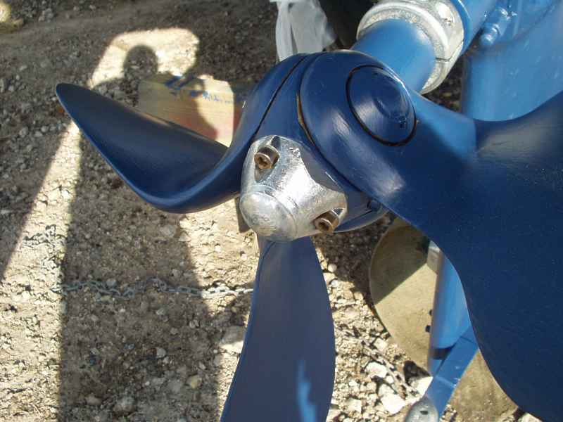
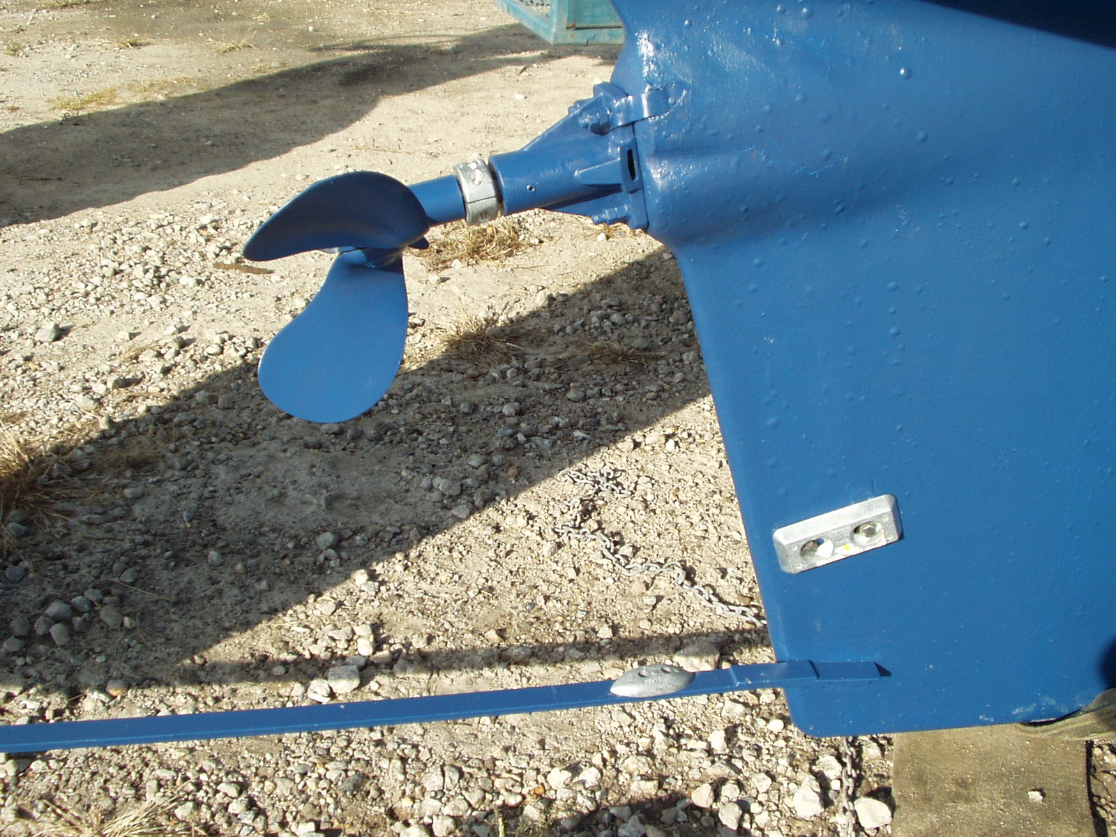
The other anomaly is motorsailing at sea. When the seas are over 5 feet and from the stern quadrant, the up-and-down motion of the boat can set up a very slight vibration if RPM's are 1400 or below. This seems to be because the prop now has to repitch to compensate for vertical velocities as well as horizontal. At 1500 RPM or above, the slight vibration is gone. This is not unique to the Autoprop as I have experienced the same phenomenon with a fixed prop. Also, the prop spins slightly above 4 knots if in neutral. It doesn't spin when the boat is shut down and left in gear. A shaft brake is not needed

Autoprop & lobster-trap guard on Tayana V-42 Autoprop on V-42

with a Hurth transmission.
Bottom line: a great prop! It’s like having an engine with 20% more horsepower and an additional 20% more fuel when on a passage. I can now motor all the way from Norfolk to Miami on one tank of fuel... Maintenance has consisted of replacing zincs and rotating the shaft monthly to clear fouling from the bearings. The greatest benefit will be to those boats with a prop that is poorly matched. Each Autoprop is custom-made for each boat based on the engine horsepower/transmission drive ratio.
www.autoprop.com/

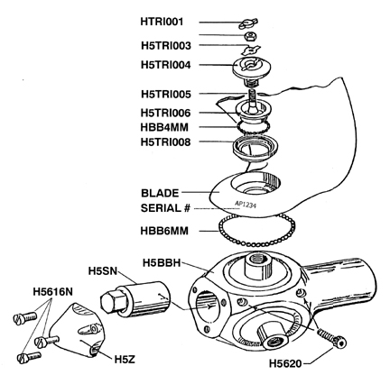

H5BB-AutoProp-Breakdown

