Cell phones and the Internet Underway

by Wayne Strausbaugh

Cruisers are always hoping that their next marina will have Wi-Fi service but often will settle just to have their turn on the dialup connection in the marina office. Many don’t realize that the same cell phone that has become indispensable for making that marina reservation can also give you broad-band Internet access sometimes even at anchor. The east coast has cell phone service almost everywhere a boater cruises except for limited areas along the ICW where it winds through true backwaters. An external antenna can dramatically increase range for those cruising there or just offshore. The west coast, of course, has limited marine service due to the mountainous terrain.

Cell phone service has come a long way with Internet connection speeds now faster than the standard dial-up speeds of landline phones. Some cell phone companies (Alltel is used an example here) can now provide broadband speeds in many cities and the service should expand quickly in 2006.

Compared to the cost of everything else on a boat, cell phones are one of the few things where prices have fallen as capability goes up. You would expect to pay a premium for this kind of service and when coverage is more complete, prices may increase. But for now, this emerging network appears somewhat misunderstood even by the local phone representatives. Prices are much lower than people might expect.

Alltel Internet access is an additional $6/month. Phone minutes must be used during access but with 500 (National) and 700 (local area only) minutes offered for $40/month, the overall rate is little more than what many of us pay for broad band connections at home. See Alltel.com. On both plans, unlimited nights and weekends plus mobile-to-mobile are included. If you used your phone for nothing more than Internet access, you could average over 30 minutes a day with the local plan without exceeding your minutes. And after 9 PM at night and on weekends, unlimited minutes and Internet access would be available.

How do you connect to the Internet? Using the phone itself with its color screen, you can connect directly to just about anywhere on the “net”. Almost every phone offered this year has Internet capabilities – even the “free” models. But with the small screen, sites optimized for mobile devices load fastest and are much easier to view and navigate. Local, animated weather radar is especially handy –and it’s free (I get it with the push of only one button on my RAZR!). Marine weather is available not only for where you are but also for your destination even though it may be far out of range of your VHF radio Real-time buoy reports and weather fax charts are available. And of course news, sports, and stocks are common selections. You can even send and receive basic E-mail.
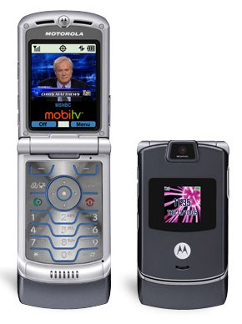
Ever wish you had the Weather Channel underway? Especially when the tropics are active and a hurricane is forming? How about live TV for only $9.99/month extra? Hard to believe but some cell phones can get you tuned in now! The Weather Channel, Discovery, TLC, MSNBC, Fox sports and news, CNBC, History Channel, ABC & CNN news plus about 15 other channels. See MobiTV. Although a bit jerky at normal Internet connections speeds, it is frameless on high-speed connections and almost as smooth as any regular TV. Although some cell phone companies charge extra for the “data packets” downloaded to display TV, Alltel doesn’t. It just counts against your minutes. And since you tend to watch short news stories and other small snippets, minutes are not really a problem. But the really good thing is that you don’t incur a commitment. Going cruising for a couple weeks? Download the application (it only takes a couple minutes) and pay for it just for one month. Then delete it when you return. You don’t even have to notify your phone company. They know when you download and activate it and when it is deleted. Getting a new phone that doesn’t support this feature is going to leave you wondering why you didn’t spend the extra $50 to $80 to get a TV-capable phone. You could be stuck with old technology and a two-year commitment. Ouch!

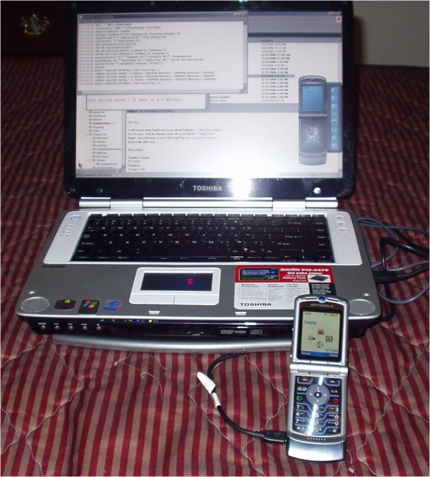
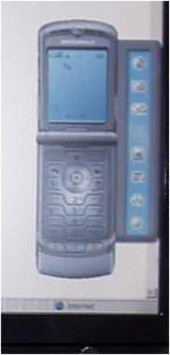
But the best deal for those who travel with a laptop or for those who want Internet on their boat is the ability to connect a cell phone to a computer. With the Motorola RAZR V3c offered by Alltel, the necessary software CD and a cable to connect to the computer are just $17.99 at Eforcity.com. When I installed the software, a picture of my phone appeared on my computer and connecting to the Internet just took a single click. The software configured itself and even grabbed my E-mail settings from Outlook Express. I didn’t have to set up anything. I was not only surfing the Internet at better than dial-up speeds but could send and receive E-mail either through Outlook Express or by using the phone software itself.

Using the slower speed Internet connection that is available almost everywhere, download / upload speeds were 110/53 kbps (a landline phone is 56 kbps max download). The company adver-tises speeds as “2 to 3 times dial-up speeds”. I often found them slower with average speeds about 1 ½ times faster than dial-up. But when I tried the EVDO high-speed connection when I was near a large city (What is EVDO?), I tested out at a fast 686 kbps download with a slow 52 kbps upload. It was obvious while surfing the net that this was true broadband speed. As fast as DSL! As a comparison to cable (which is faster than standard DSL), my TV cable speeds tested at 1670/470 kbps.

Of the EVDO capable phone services; Alltel, Verizon and Sprint all charge extra for connecting your cell phone service to your computer with a PC card or via cable and a handset. The Motorola E815 and RAZR V3c are the only Alltel handsets capable of EVDO broadband connections (as of August 2006). Smartphones (Blackberry, Palm Treo, etc.) can access EVDO as well, see Smartphone data rates. Fees are charged by the kilobytes of data transferred or include an unlimited monthly option which is even available nationwide, Alltel Axcess MobileLink/Broadband. Ranging from $60 to $80 a month for unlimited data with a handset, this only sounds expensive until you consider the advantage of this service from a boat. Maybe you can just skip that marina tonight! Or just the ability to access the Internet anywhere/anytime from your computer without reconfiguring connections could make it worthwhile. Alltel’s broadband web access from the phone itself or while using applications such as MOBI-TV doesn’t cost any more than the slower speed access. It is still only charged as “minutes used.”

One other interesting but less useful Internet capability is something called “Share” by Motorola. I downloaded a free copy at the Motorola website and installed it on my laptop. This software makes any computer accessible over the Internet by cell phone with an interface optimized for the phone’s small-screen. When I left my laptop on and connected to the Internet using its cable connection, I could then use the cell phone to access any picture or text file on the computer from anywhere the cell phone would work. If nothing else, it is a great way to transfer pictures to the phone. Passwords and seamless encryption are used for security. Others may be granted access to your computer as well.

Bottom line: this technology is operational now. We are on the threshold of having full time, broadband Internet access - everywhere and all the time. This will change our lives in ways we cannot even begin to predict… The next time you renew your cell phone contract, don’t get left behind. This is finally something really worthwhile that doesn’t cost a whole “boat unit”!

