Chainplates For 1985 MKII T37

Situation
1. Removed covers and cabinetry to inspect chainplates and knees. Found wood in all knees to be in good dry condition, (whoop whoop) found all chainplates themselves suffering from different levels of crevice corrosion and found two bolts on the forward lowers to be corroded in the middle. One was so bad it fell apart into several pieces. It is to be noted that the corroded bolts were the ones where the green bonding wire was attached obviously setting up the battery between the stainless rigging, aluminum mast and copper strap and what ever it might actually be connected to (if anything).

Plan
2. Decided to re-use all knees as found with original bolts. Forward knees port and starboard to have all bolts removed and rebolted to the outside of hull using external backing plates. Stays to stay in current position. The middle bolt on each side was left in place mostly because they ran straight into the rubbing strake, but also to provide a centering pin for a step farther down the process.

Execution
3. Operations to go like this:

a. remove each bolt without disturbing the wood and fiberglass around it;
b. fill the void in the back of the knee with thickened epoxy;
c. fill the bolt holes with thickened epoxy and place bolts into each hole to keep the bolt hole to act as a guide before drilling the bolt path out to the outer hull; and
d. place new chainplates on inside of knee and through bolt to backing plates on outside of hull.

Method
4. First I got a plate cutting bit from B&A Manufacturing in Florida. http://www.bamanufacturing.com/ (Took me a while to find these guys but they knew what I wanted to do without asking about the turnip growing out of the top of my head). This is what Mike at B&A wrote of what they did for me:

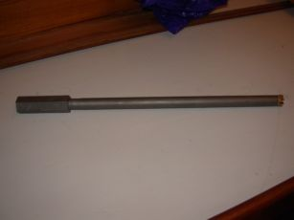

My original idea was to bore tightly down the shaft of the chainplate bolt until I hit the head and then just cut the head off the bolt and go through the retaining strap in turn. It didn't work out quite that way but close. I found that if the plate cutter was shimmed close to the bolt it would inevitably cut too close to the bolt and flare the tooth thereby destroying the bit. This was really easy to do. Drilling too close to the bolt also prevented saw dust from exiting the hole without a lot of pulling the bit and clearing the hole which helped the flaring tip problem be worse. The successful technique was to follow down the bolt quite loosely allowing the bit to wobble around. This also had the side effect of easily clearing the saw dust from the hole. When the bit hit the bolt head it went right through with no problems. …. and out popped the whole thing.

