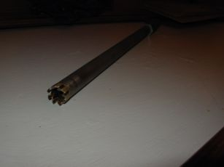

I then cut the top off the old chainplate and pushed it back onto the leftover center bolt. Then I took carriage bolts and ran those through the chainplate to the depth of the hull through the knee. Next was to secure the carriage bolt in that position using a nut on each side to keep the depth securing the carriage bolts. Then I found about 8" of doweling of the diameter of the hole drilled. Using the doweling I pushed tons of thickened epoxy down the holes and into the void (doweling acted as a hydraulic ram). When the voids filled up the epoxy came oozing out of the other bolt holes. I did however, shove epoxy into each bolt hole until the hole would accept no more and the epoxy was flush with the entrance of the hole.. As the voids became full the feel of pushing the dowel was very firm and epoxy oozed back up the push.

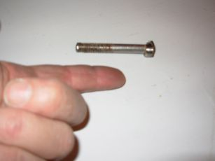

When building the "depthed chainplate" - the one waxed above, I used 3/8" carriage bolts and their corresponding nuts. I found the nut on the contact face of the "depthed chainplate" would go just nicely into the bored out bolt hole an this fit along with the last original bolt left in place (in the middle position) centered the whole thing when shoved into the still wet epoxy (did a dry fit before doing the epoxy part).

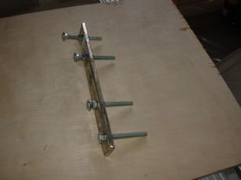

So when one side was completely stuffed with epoxy, the "depthed chainplate" was shoved down into the holes as one assembly and secured on the original center bolt.

Whew!

OK. A day later the chainplates were removed while the epoxy was still fairly green. Just unscrewing them with a spanner worked fine. The inside nut popped out with a flathead screwdriver (one of its only uses). A day after that when the epoxy wouldn't clog the drill bit the pilot holes were drilled through to the outside of the boat.

Conclusion

Would I do this again for the rest of the chainplates as they require? Yes. Getting the plate cutter and using the correct drill method was the hard part.

As of this writing the backing plates are being made and the new chainplates are out for polishing. When the 'hole' process is complete I'll update this file.

JD
#375
DayDream

