Replacing windows on a T37 Pilothouse

Although the work on the pilothouse is extensive, I have included the steps to replace the pilothouse windows. Please note that these windows were not designed to be replaced easily. The method I used at least kept the glass intact, though I will be replacing it since it has signs of water intruding into the laminations.

- Interior signs of water leakage
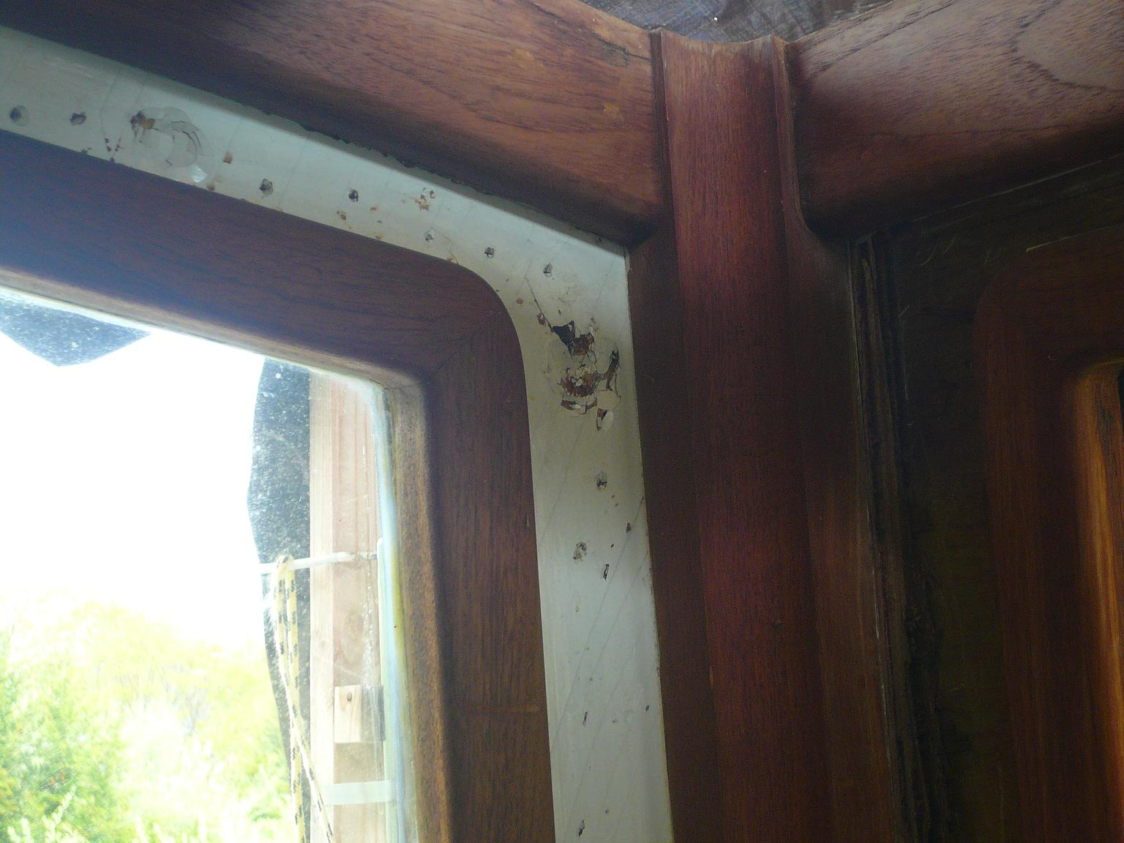

- Telltale sign of water intrusion into laminations
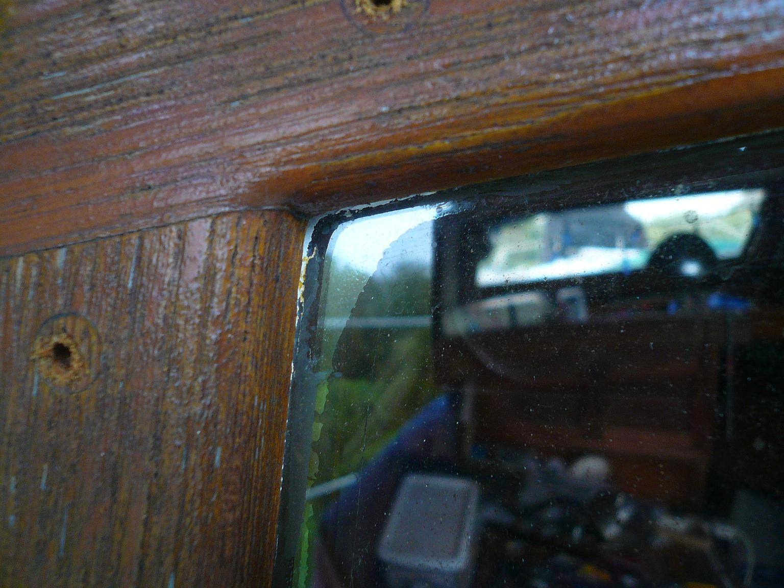

- Exterior bung removal
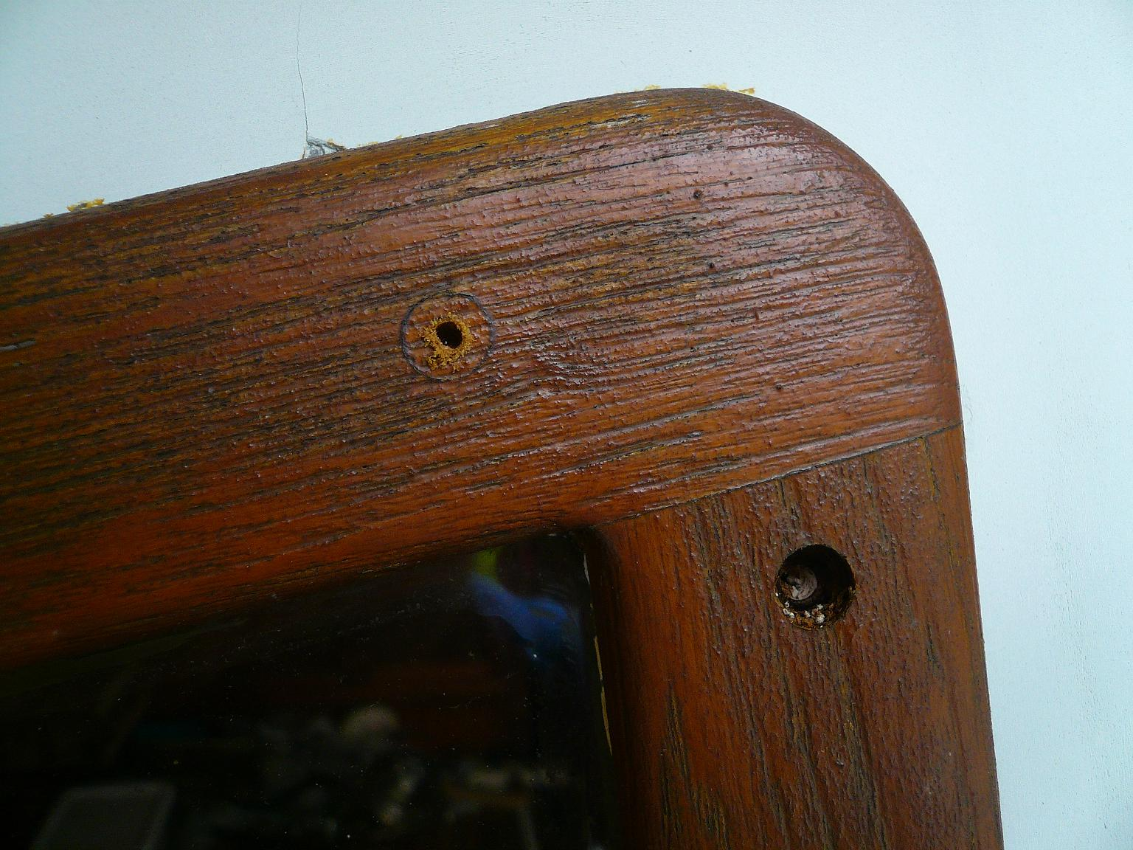
- Removing the exterior frame with my new best friend (Harbor Freight Multitool)
Note that the gentle action of the tool does not mar or break the glass!
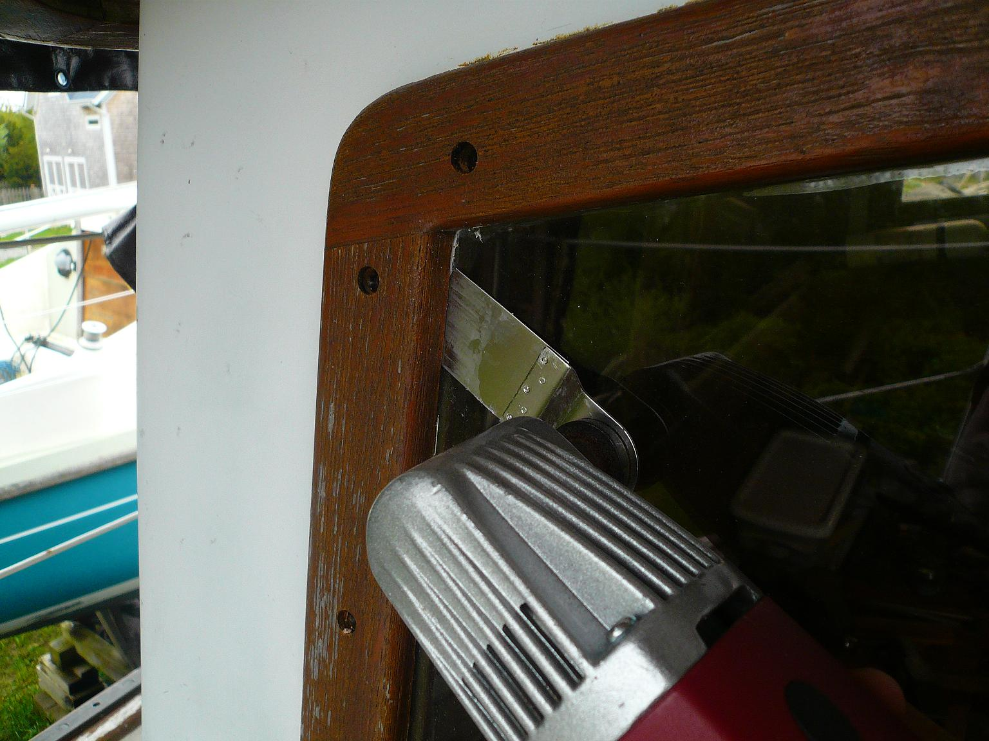
- Gently pry the frame using flat stock nail pullers. Use a sheetrock knife or the Multitool to cut through the Black Goo as you gently separate the frame from the wall. Move slowly as the frame is thin and will crack if you try and remove it too quickly.
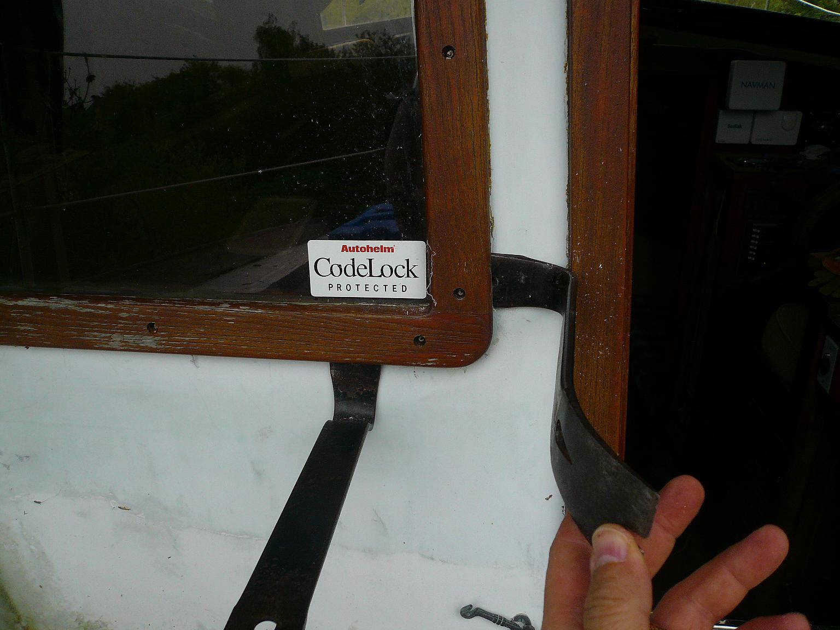
- Exterior frame removed
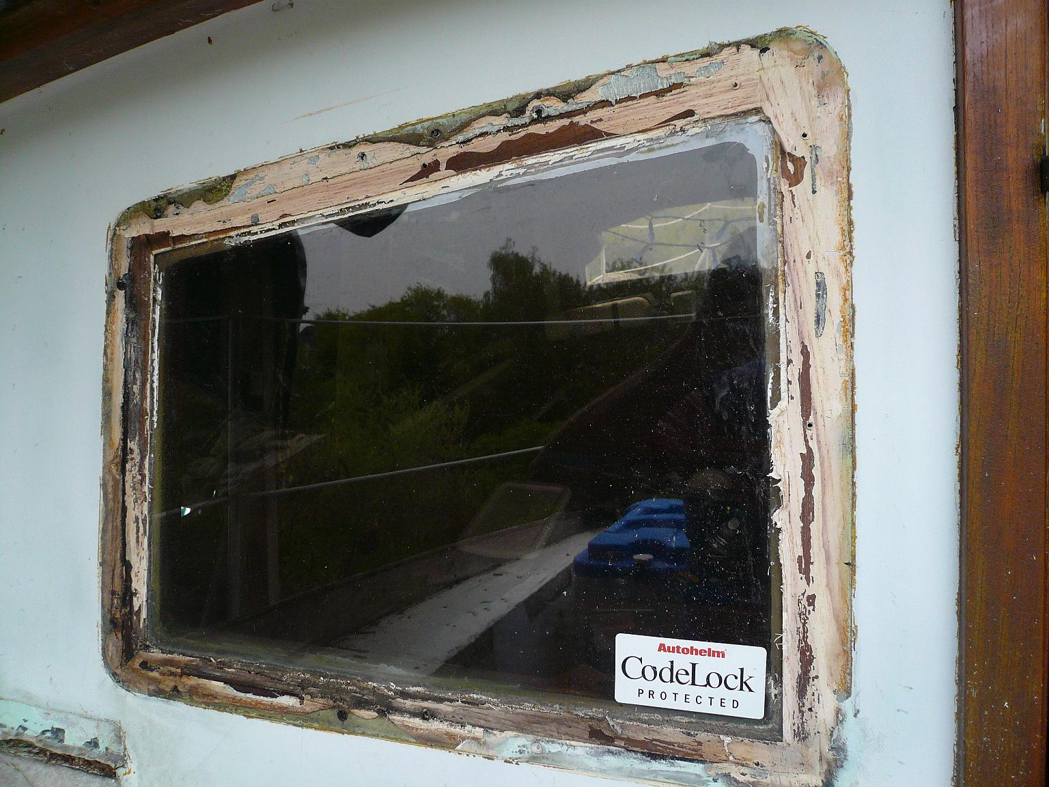
7) Remove the exterior screws that hold the frame to the wall. This step is actually much more complicated than the picture shows. The window is sealed inside and out with gobs of goo. This part can easliy take ½ a day to do! 