Tayana 37 - Ladyfish

Winter cover design
Winter 2006

My situation:

I have removed the mast and all the stanchions/lifelines. Most boat owners in this area all pull their mast as part of the winter lay-up ritual. The design could be modified to accommodate a mast however this was my specific requirement.

My boat also sits on a trailer which allows me to get her home to work on during the off season. As a result, it is equipped with ample spots to tie down the tarp and netting. You will need to figure out a way to anchor these down since they are critical to the design. (Screw-in ground anchors used to distribute the load similar to the way I designed the tarp skirting could be mad to work). Some of the tarp could also be secured to a cradle base? In any case, this is something you will need to figure out.

Design requirements:
- Ability to withstand elements
- Ability to access all areas of the boat for maintenance
- Reusable (the rib structure should last for several years, I hope to get 2 seasons out of the plastic )
- Low cost

Key tools needed:
- Chop saw/Miter saw – very helpful for accurate angles
- Cordless variable speed drill – good while on the boat
- Measuring tape
- Carpenter square

Materials:
- Lumber (I used rough cut spruce as this was the lowest price material available)

Item Description | Material Type (spruce) | Qty
Sides pieces (18 – various lengths (see table) | 2”x4”x8’ | 18
Stand-off’s (16 @ 24” each) | 2”x4”x8’ | 4
Legs (16 @ 32” each) | 2”x4”x8’ | 6
Long legs (2 used for back truss only -length depends on your situation) | 2”x4”x16’ | 2
Strapping (binds all trusses) | 1”x3”x16’ | 21
Bottom “skirt” strapping | 1”x3”X16’ | 6

- 6mm Plastic Tarp (40’ x 60’)
- Cargo/trawler netting (40’ x 20’)
- 2 ½ ” wood screws (sheetrock screws)
- Scraps of foam used to protect the plastic on sharp truss corners (I used old carpet underlay)
- Duct tape to secure the carpet to the truss (don’t use staples – rust stains)
- Rope used to secure the plastic and cargo net

Approximate build time:
- 1 day to cut/prep and build trusses (1 person)
- 1 day to erect trusses (2 people)
- 1 day to tarp (2-3 people)

Construction overview:

I cut and assembled all 9 truss units for the boat. I positioned 8 of these on deck approx 4 foot centers starting with the first one (truss #8) in the cockpit just over the binnacle. This position was the farthest aft that the 3 inch legs would fit outside the cockpit (between the cockpit combing and the toe rail). Truss# 9 is actually erected off the stern and sits on long legs down to my trailer (or ground). I designed it this way so that I could keep the tarp away from the hull at the stern. As it turns out, it also allows me to store and load/unload larger items off the stern while keeping it out of the rain and snow. It also makes a good entry point (dry) to get on/off the boat.
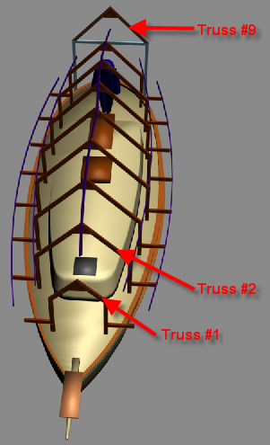
After I finally decided to use 6mm plastic (cost and weight) to cover the boat, I didn’t want it air tight and cause a bunch of mold issues. I also wanted full access to the hull in order to do minor repairs and cleaning. The solution I came up with was to use stand-off’s which protrude over the toe rail and extend beyond the hull. I screwed 1x3 strapping to the ends of these.

The 1x3 strapping is also screwed to all 9 trusses and provides the structural support for the cover. In addition, I diagonally braced (cross braced) trusses #4 and #5 for lateral support.

I used 2 ½ inch screws to fasten all the wood. My thinking was that if something needed to be taken apart later on it would be easier than pulling nails. They are also stronger.

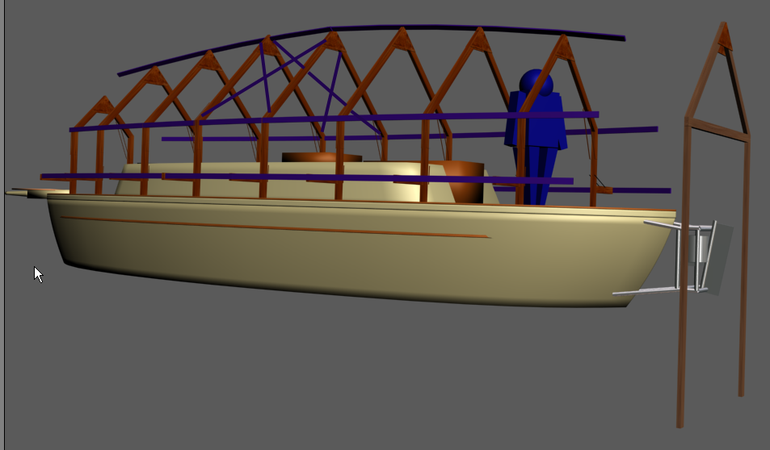

The 9 truss components are basically all cut the same with exception of the sides. The side lengths are critical since they dictate the overall width of each truss. The following table shows the required lengths of the two side pieces for each truss.

Figure 1
Position on deck | 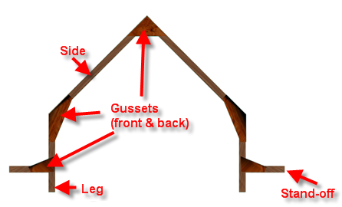  Truss side length (inches)
Truss #1 (bow) | 38”
Truss #2 | 65”
Truss #3 | 76”
Truss #4 | 85”
Truss #5 | 85”
Truss #6 | 81”
Truss #7 | 76”
Truss #8 | 65”
Truss #9 (Stern) | 65”

The lumber I used for the truss construction was all rough cut spruce 2”x4”. For the gussets I used 1/2” plywood. To tie it all together, I used rough cut 1”x3” spruce strapping. I bought the 2x4’s in 16’ lengths to reduce waste (8’ lengths will also work). The strapping should be all 16’ lengths in order to tie three truss units together at once. You will also use these lengths to distribute equal tension on the plastic tarp (discussed later).

Cutting the truss components:

Stand-off’s:
- Cut 16 stand-off pieces each 24 inches long (none used on truss#9). Both ends are straight cut ends.
Legs:
- Cut 16 legs 32 inches total length.
  - The top of each leg needs to have a 22.5 degree angle to mate with the bottom of the side which will also have a 22.5 degree angle.
  - NOTE: The two legs for truss #9 can be measured to fit you specific situation.
Sides:
- Cut the truss sides (two per truss) to the appropriate overall length as identified in the table above. Note: These measurements determine the overall truss width and are critical to the fit on deck. It also helps to mark the length/truss # on each for assembly later.

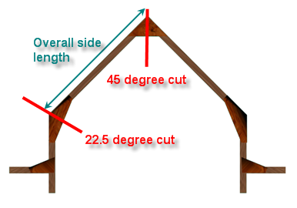
  - The bottom of each side, where it joins the top of the leg, needs to be cut at 22.5 degrees.

  - The top of each side, where it joins the opposite side needs to be cut at 45 degrees.

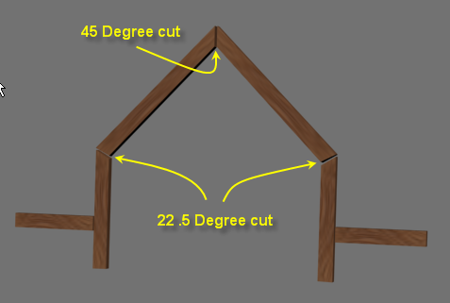

Gussets:
- There are three gusset types used for each truss. They are all made from ½ inch plywood. Each truss has a total of 10 gussets (5 on the front and 5 on the back of the truss) these are shown in the following diagrams.

  - Top gusset – This is simply a right angle triangle with the two equal sides 18 inches long. Two of these join the top side sections. (Total top gussets = 18)

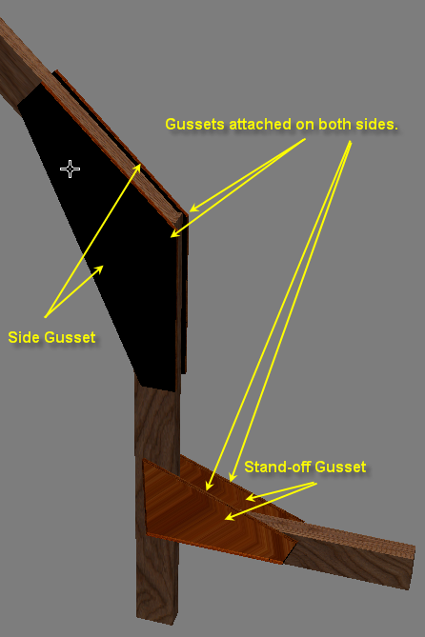
  - Side gusset – 4 of these join the 2 leg and the 2 side sections. The dimensions are shown below in the diagram. Note that the two smallest ends (each is 3 ½ inches long) are actually tapered in toward the 19 inch base. (Total side gussets = 36)

  - Stand-off gusset – 4 of these join the 2 leg and 2 stand-off sections. These are actually side gussets cut in half. (total stand-off gussets=36 or 18 additional side gussets cut in half)
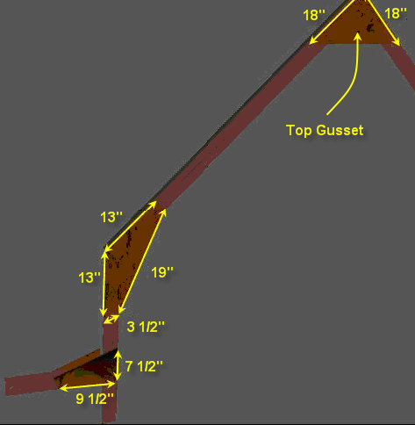

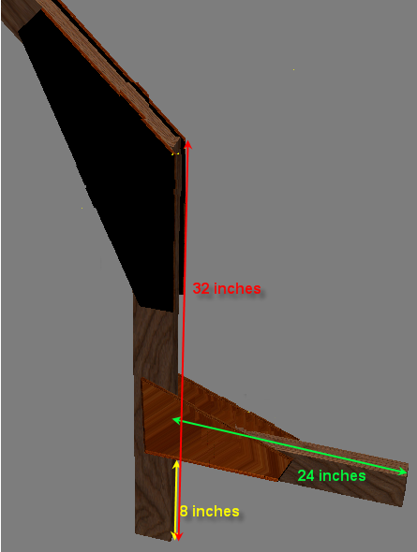

Assembly:

- Starting with truss #1 (smallest), lay out all the pieces in order (I did mine on the driveway).
- Square up the two sides at the top (the two 45 degree cuts)
- Screw the first top gusset into both sides (use plenty of screws) I averaged about 16 – 20 screws per gusset (it is a lot but this is what gives them strength). You should also set all gussets in a ¼ inch so as not to minimize exposure any sharp edges to the plastic tarp.
- Fit and secure the rest of the gussets on this side and then turn the truss over and complete the back side.
- Clearly number the completed truss and put them in the order that you will need them. I didn’t and ended up having to move some around on the deck (not fun).
- Complete this for the rest of them except #9. Note: If you decide to do the same with truss #9 (erect it off the stern) then you may want to wait and fit it as required. I found it easier to build/erect this one (long legs) after the rest were up and strapped together.

With some masking tape, I marked off 4 foot increments along the center of the deck as a guide for the truss positions. You will need a hand getting them up and positioned on deck as they are awkward. I started by positioning truss #8 just over the binnacle followed by #7, approximately 4 feet forward. I used the strapping to secure them upright. At his point I only used temporary straps until I got the third one in place. The reason for the 16 foot strapping is to be able to strap 4 trusses together with one length. The diagram shows the strapping layout (purple) that I used.

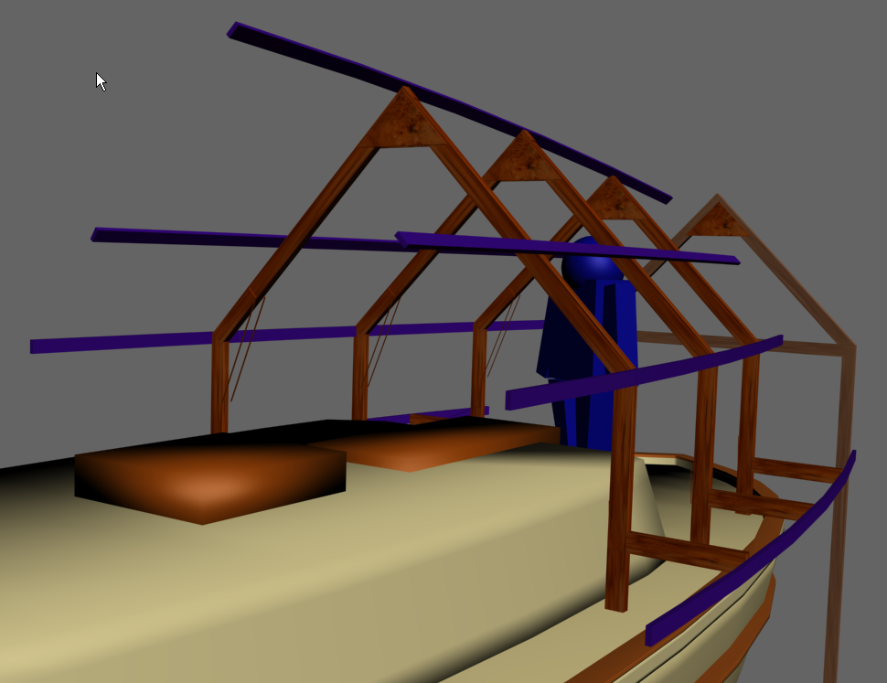
The most difficult part of this was screwing the strapping to the stand-offs. My boat sits on a trailer which adds another 2 feet off the ground. The strapping needs to bend in order to conform to the hull shape. I had a friend pull the strapping in from the deck with a rope. I then screwed the strapping to the stand-off’s with a ladder from the ground. The other strapping issue I ran up against here was that sometimes the end of the strapping would not match up the centre of the truss. This was due to an oversight in my design, (I didn’t take into account the curvature of the structure). When this happened and I needed to “extend or bridge” two sections of strapping, I simply placed a 3’- 4’ length of strapping behind the two pieces screwed them together.
Completing the ends and padding sharp edges:

The strapping all came together at the bow. I tied it with rope and secured it to the bowsprit. Erecting the stern was awkward however once it ties into the existing structure it is solid. The long legs on my truss #9 are secured to a trailer (screwed down to a wooden deck). They can just as easily be staked into the ground to provide the same support. This is why I recommend you do this one last since the height measurements can vary.

At this point I have a completed rib structure.

Now I took chunks of foam underlay and secured them with duct tape along the top ridge of the structure and any other “sharp” places that I thought could possibly damage the tarp.

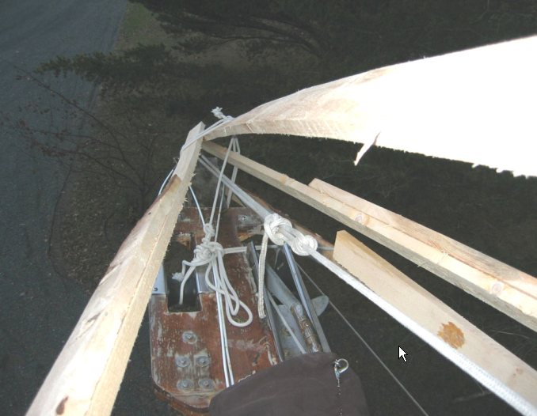
Bow tied together:
Tarp and netting:

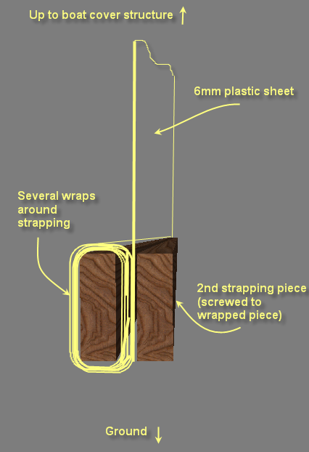
The plastic tarp went on without much issue. Even in the lightest breeze though, this monster (40’x60’) can be tough to hang on to. I can’t imagine having to haul up a canvas one.

The 6mm plastic lies evenly over the boat ribbing. Once that was in place, the cargo netting goes on next. This netting is what actually keeps the tarp from flapping wildly in the wind. The only issue with installing the netting is that you can’t easily access it since the plastic tarp is now between you and the netting. We used ropes to get the netting in place. Care must be taken so that the ropes don’t burn a hole in the tarp as you try to coax the netting in place. Once in place, we secured it to the edge of the trailer/ground/cradle.

The next step was to take the excess draped plastic tarp and, starting from the aft starboard side, roll it several times onto a length of 16’ 1x3 strapping. Then take another length of 16’ strapping and lay it flush against the one with the rolled plastic creating a type of plastic sandwich (see diagram) and screw them together.

NOTE: In order to get a tight “sandwich”, I used two hand clamps to secure them prior to screwing them. I discovered this on the last ones that I did myself. I went back and redid some of the others because I thought they were too loose.

I did this all the way around the base of the tarp leaving a couple of feet of no rolled strapping between the 16’ lengths to act as a hinge/bend point for the hull shape. These hinge/bend sections, which are force rolled anyway by both sides of rolled strapping sections seem to stand up better to wind than if they were just plain exposed edges (they don’t fly around as much). I also rolled the plastic leaving about 2 feet of open space under the entire skirted tarp between the trailer/ground and sandwich. I figure that it would provide an escape path for large winds and also provide good ventilation (see photo below). So far this has worked through two good blows.

After all the base edges were rolled and screwed together, I drilled 3 x ¾ inch holes through each sandwiched edge, one on both ends and one in the middle. I then used these holes as anchor points for securing ropes back down to the trailer deck. This gives the plastic tarp an even distribution of pull over a very large area and has worked great so far.

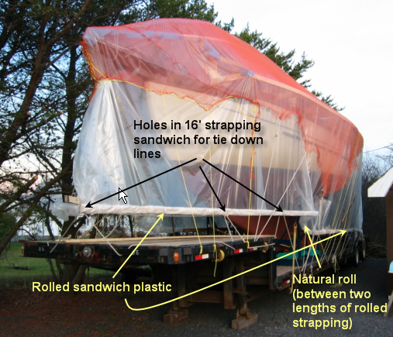
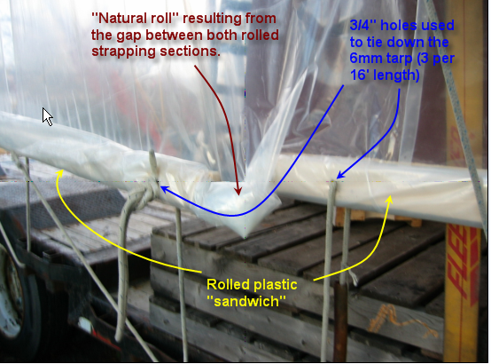
Observations and comments:

The clear tarp is great and so far is very well suited for working under in the daylight. There is no wind on deck which helps when working in winter temperatures. Ventilation is excellent.

I did notice some spruce sap on the deck as a result of using rough (not kiln dried) lumber. The warm temperatures under the tarp cause this. This is a minor issue since it comes off easily with mineral spirits.

Most of the prep work (cutting and frame assembly) can be completed alone. You will definitely need at least one other person to help get the trusses on board, the strapping screwed in place and the tarp/netting fitted. I had two friends who where invaluable (thanks Barry and Jim).

I should also mention that my boat is somewhat protected from both sides (sits between a row of pine trees and a garage) however the top ridge of the tarp extends above the garage roof.

In the spring, after the tarp is removed, I hope to utilize a boom truck (or rig something up) and lift the entire rib structure off at once. I will then do the reverse in the fall to set it back on and simply tarp the thing.

So far so good however the winter is far from over. Our winters have potential for serious havoc and I can only hope that my design (a lot of time spent in front of my computer) will hold up. The actual truss structures are very strong and I expect no issues with respect to vertical snow loading. The 45 degree slope will ensure that nothing accumulates on the structure.

I will try to keep posting comments and photos of any issues that come up. If you have questions please feel free to email me.

Thanks,
Christian

Other photos:
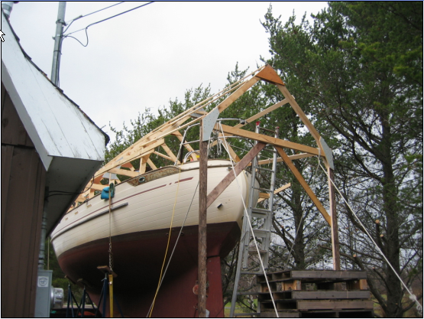

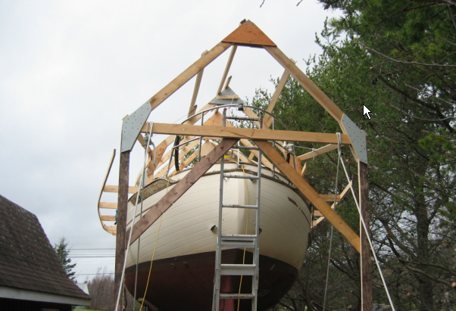

Inside:

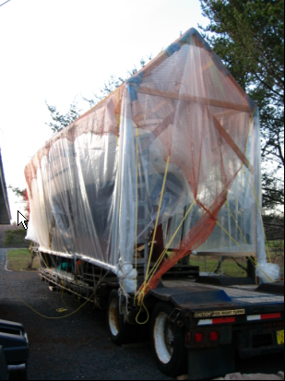
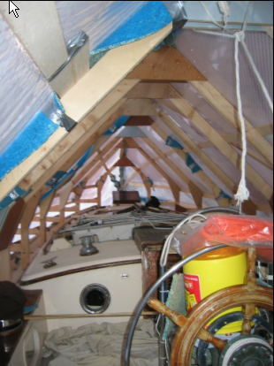

Stern entrance (looking down off the stern):

